Network Management Workshop
Request Tracker

1. Install RT packages

apt-get install mysql-server-5.0
apt-get install rt3.8-apache2
apt-get install rt3.8-clients
apt-get install rt3.8-db-mysql
apt-get install request-tracker3.8

When asked for the ”Name” of the RT installation, call it ”NETMGMT” (it could be anything, but we use this for now):

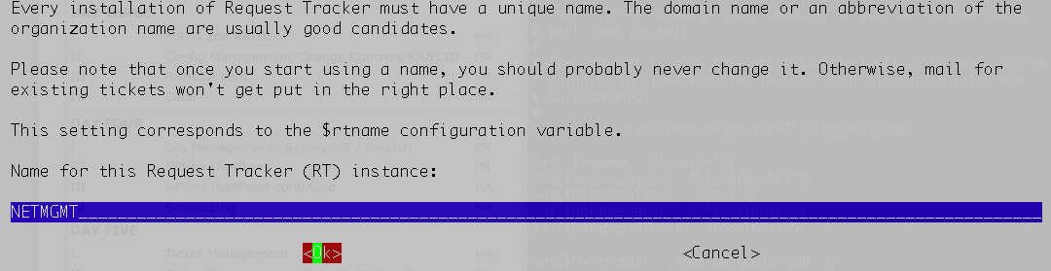
When asked about the DB Password, enter the mysql superuser password (it should be "apr10cot"):

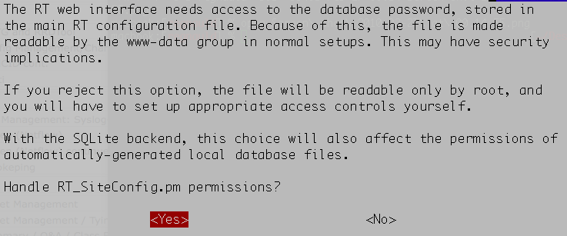
Choose <Yes> to other questions.

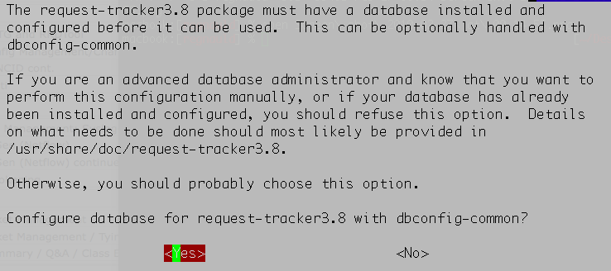
When asked to provide a password for RT DB, leave blank and just select <Ok>

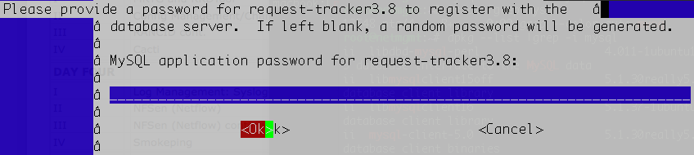

2. Enable RT in Apache

# cd /etc/apache2/conf.d
# ln -s /etc/request-tracker3.8/apache2-speedycgi.conf .
# /etc/init.d/apache2 reload

RT configuration

3. Go to the web interface

Open the link: http://localhost/rt/

Default Web login for RT is "root", password is "password"

4. Create a user

Click on Configuration (left menu), then Users
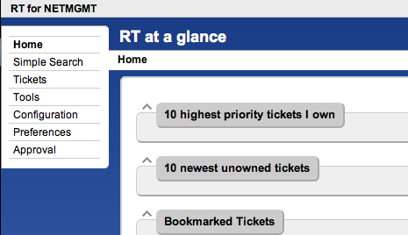
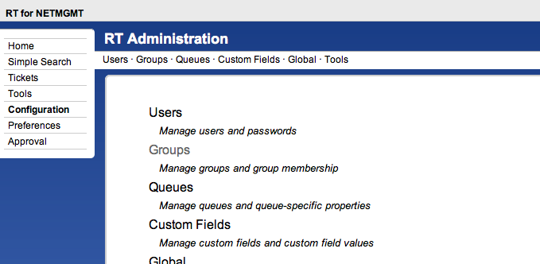
Click on Create (top menu)

Fill in the fields, and make sure the checkbox "Let this user be granted rights"
is checked.
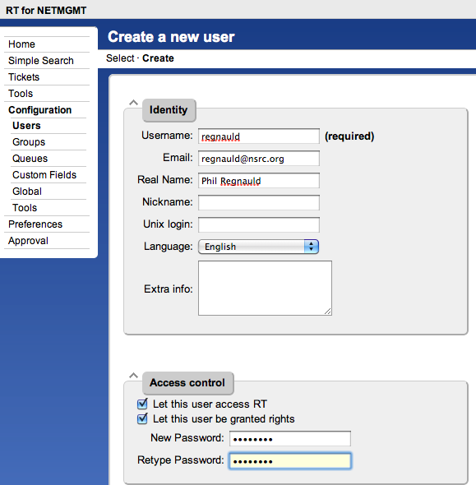

Click on "Create" (bottom right), to save the user.

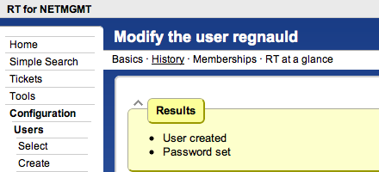

5. Create a group

Click on Configuration (left menu), then Groups
Click on Create (top menu)

Fill in the name: "netmgmt", and add a description, then click on "Create"
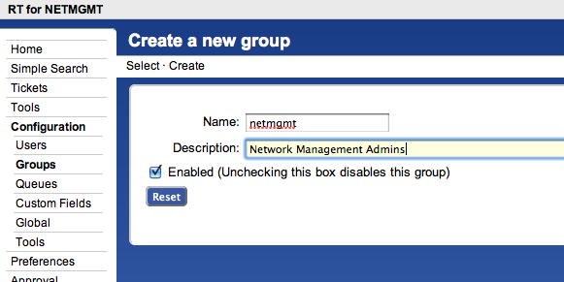

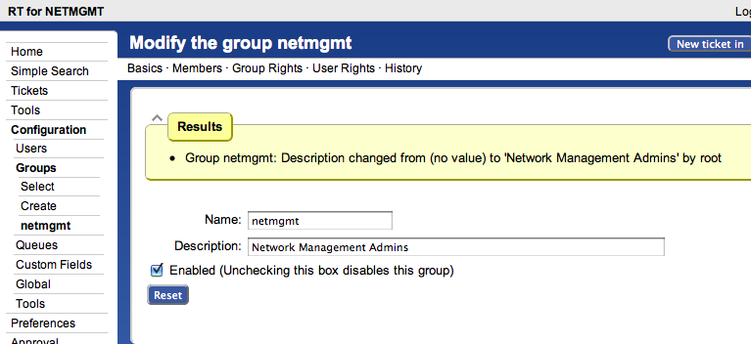
6. Add members to the group

Click on Configuration (left menu), then Groups (left menu)

Click on "netmgmt" (the group you just created)

Click on Members (top menu)

In the "Add members" list (right), select the user you created in step 4.

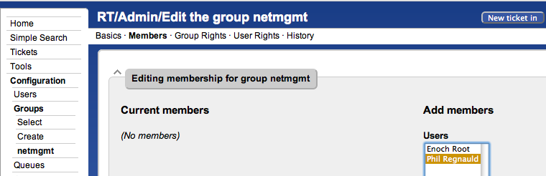

Click on "Modify Members" (bottom right)

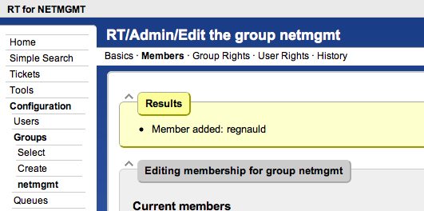

7. Let's create a new Queue

Click on Configuration (left menu), then Queues
Click on Create (top menu)

Fill in the fields, remember to replace X with the number of your PC.

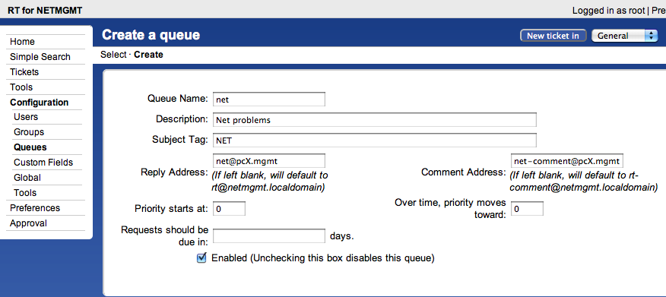

Click on "Create" (bottom right)

8. Let's give rights to the Group on the Queue

Click on Configuration (left menu), then Queues

Click on "net" (the queue that you just created)

Click on "Group Rights" (top menu)

In the "Everyone" Group, select:

"CreateTicket"
"ReplyToTicket"
"SeeQueue"

... under "New Rights".

In the "netmgmt" Group, select ALL rights under "New Rights" (use the shift
key to select multiple), except '(no value)'

[this is illustrated on the next page]

Click "Modify Group Rights" (bottom right)

9. Log out of RT and log in as your new user (created in step 4)
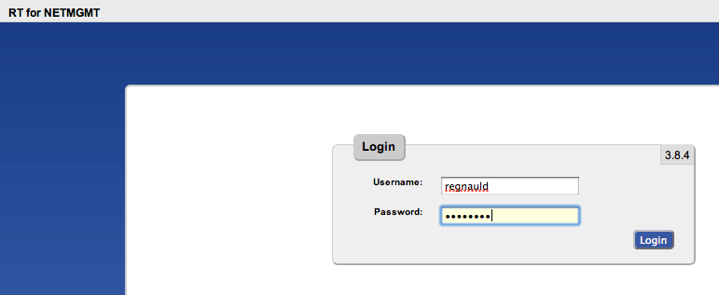
[Group Rights on the ”net” Queue]

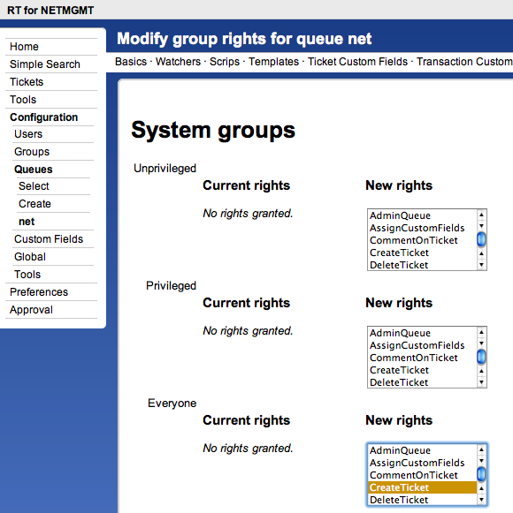

10. Let's setup email

Edit the file /etc/aliases

Add:

net-comment: "|/usr/bin/rt-mailgate --queue net --action comment --url http://localhost/rt/"
net: "|/usr/bin/rt-mailgate --queue net --action correspond --url http://localhost/rt/"

Save the file and exit, then run:

# newaliases

Edit the file /etc/postfix/main.cf

Add:

mydestination = $myhostname, localhost.$mydomain, localhost, pcX.mgmt

Save the file and exit, then run:

# postfix reload

11. Let's send some mail!

Run this as the ”mgmt” user!

% echo "Problem with my router" | mail -s "Router problem" net@pcX.mgmt

12. Check that you (mgmt) have received an email

% mutt -f /var/mail/mgmt

13. Go to the RT Web interface, and verify that a ticket has been created

Click on the ticket in the main view, and examine the page.

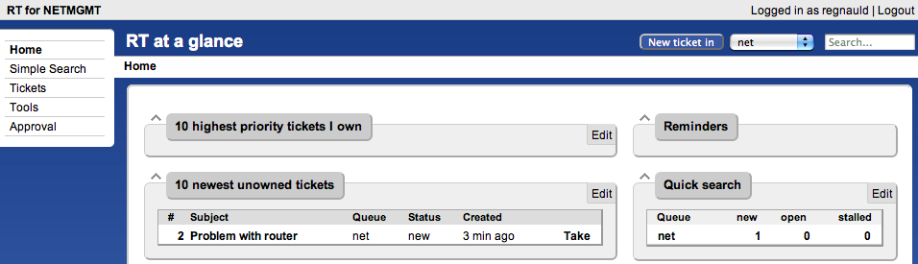

Scroll to the bottom (on the ticket)

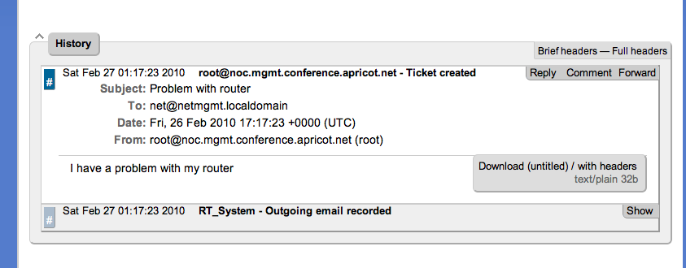

14. Reply to the ticket.

Type in a reply, then set "Status" (top) to "Resolved", then click
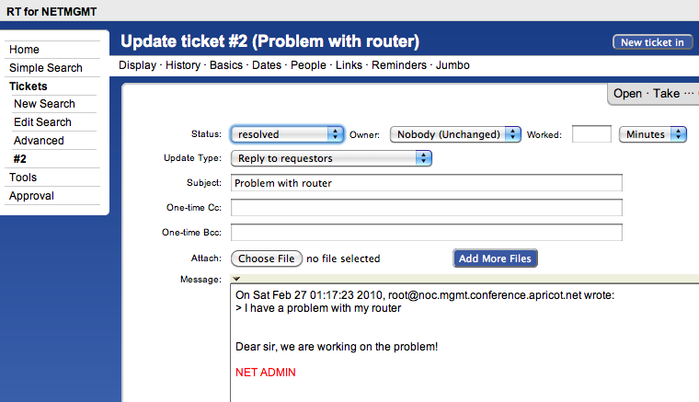
on "Update Ticket" (bottom right)

Scroll to the bottom, you will see the transactions.

Note: The ticket is now closed, but you can still reopen it:

- by the Web interface
- by replying to the email

In this case, the ticket will be reopened, and new communication will
be recorded.

For example:

