**Flatbed Scanning: Epson Expression** (8/2012)

**Using the EPSON Scan Software**

1. Turn on the scanner before you open the EPSON scan software.
2. Be sure to have the settings as follows:

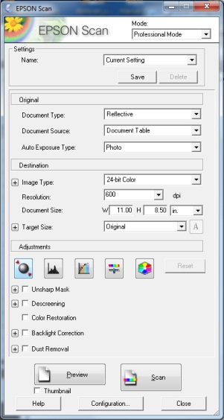

* Mode: Professional Mode
* Document Type: Reflective
* Document Source: Document Table
* Auto Exposure Type: Photo
* Image Type: 24-bit color
* Resolution: 400 dpi (for documents) or 600 dpi (for photos and images)

*\*Do not check*: Unsharp Mask; Descreening; Color Restoration; Backlight Correction; Dust Removal

1. Click on *Preview* to preview the image you are scanning. The preview window will allow you to create a *Marquee* around the specific area you want to scan. If you are scanning multiple pages of the same size, you may use the same document size settings repeatedly, just be sure to always put the document in the top left corner of the scanner bed.
2. Click *Scan*. A *File Save Settings* dialog box will appear. Choose the location you would like to save your file, name your file according to your naming conventions, select TIFF for your *Image Format Type*, and Click OK.

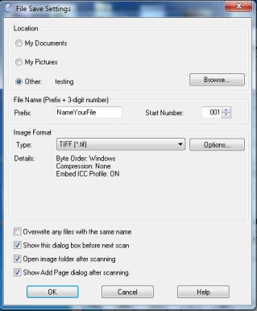

1. For multiple page documents of the same type and size, you can simply open the scanner, replace the page (in the same location on the scanner bed), click *Scan,* then click *OK* (your settings should remain the same, and the file name will serialize in the order you scan your pages).

*\*For any technician starting a new scanning session it is always good to check all of your settings. The person scanning before you may have changed the settings. Once you start, your settings should remain the same throughout your session*.