**Imaging Terms**

**RESOLUTION** - The number of rows and columns of pixels in an image. It is the ability to distinguish fine spatial detail. The spatial frequency at which a digital image is sampled (the sampling frequency) is often a good indicator of resolution. This is why **dots-per-inch** (dpi) or **pixels-per-inch** (ppi) are common and synonymous terms used to express resolution for digital images.

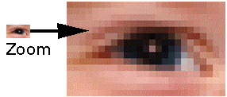

**Pixels:** Individual pixels can be seen by zooming in an image.

**Image FILE SIZE** is calculated by multiplying the surface area of a document (height x width) to be scanned by the bit depth and the dpi2.

**Histogram:** An image histogram is a type of [histogram](http://en.wikipedia.org/wiki/Histogram) that acts as a [graphical representation](http://en.wikipedia.org/wiki/Graphical_representation) of the [tonal](http://en.wikipedia.org/wiki/Lightness_%28color%29) distribution in a [digital image](http://en.wikipedia.org/wiki/Digital_image). It plots the number of [pixels](http://en.wikipedia.org/wiki/Pixels) for each tonal value. By looking at the histogram for a specific image a viewer will be able to judge the entire tonal distribution at a glance.