## Submit Items to the Cartes Postales

1. Open the jpeg version of the image to have ready to describe
2. Login to the digital repository

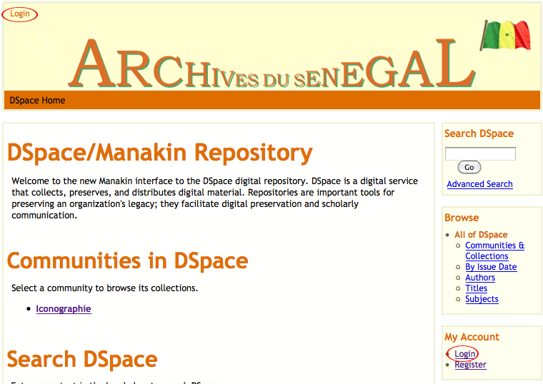

1. If you have forgotten your password, or if it is the first time you have logged in, click the “Forgot the Password” link.

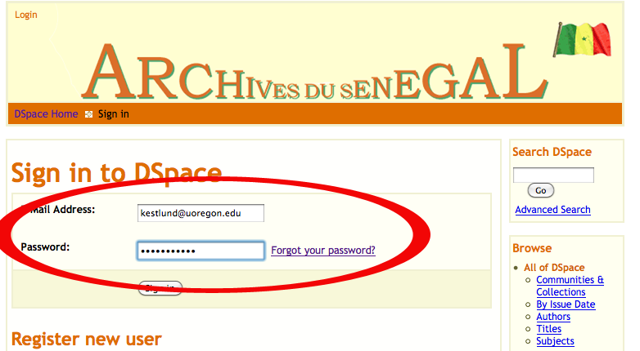

1. Click the “Submissions” link in the right column

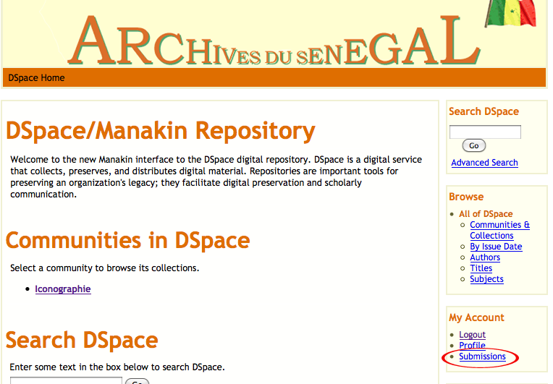

1. Click the “start a new submission” link

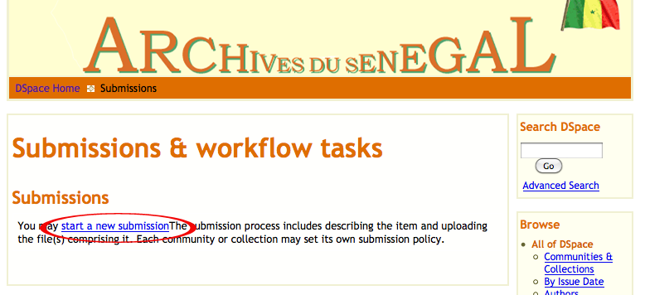

1. Select the collection from the dropdown and click “Next”

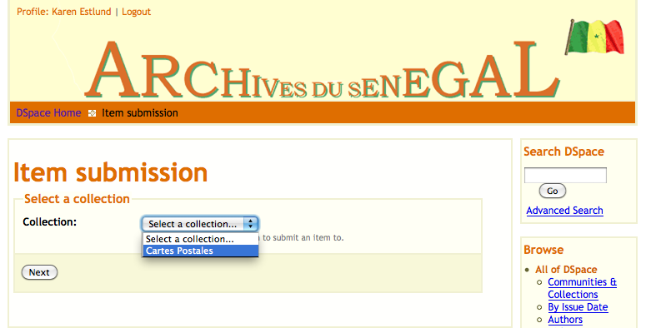

1. Describe the item according to the metadata guidelines, and click “Next”

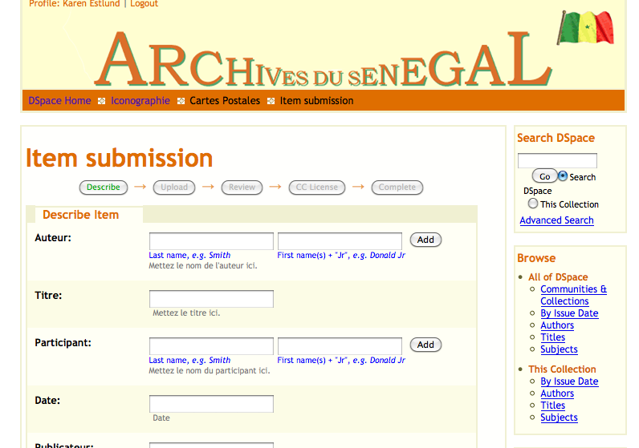

1. Upload the JPG and TIFF files, use the “upload and add another” option.  
   Give the JPG a description of “Low resolution image” and the TIFF a description of “High resolution image” and click “Next”

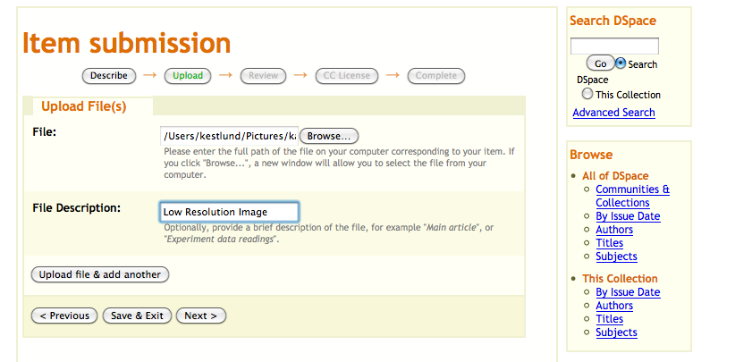

1. Review on the next screen and correct any mistakes and make any changes needed, then click “next”
2. Select “Creative Commons” with “No” for Commercial uses and “ShareAlike” for modifications

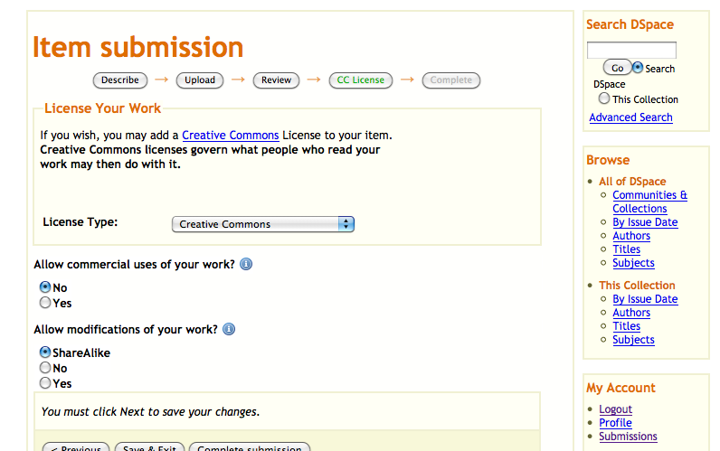

1. Click “Complete submission”