**Using Adobe Acrobat Pro for scanning and creating pdfs** (8/2012)

You can either create a pdf from tiff and jpeg files that you have already scanned in, or you can scan directly into acrobat to create a multipage pdf document.

**To scan files into a pdf document**

1. Turn on scanner before you open applications.
2. Open Adobe Acrobat Professional
3. Select *create pdf* 🡪 *from scanner*… 🡪 *custom scan*…

Be sure that the correct scanner is selected, and under Options select Native Mode and Show Scanner’s Native Interface. Click OK and click Scan.

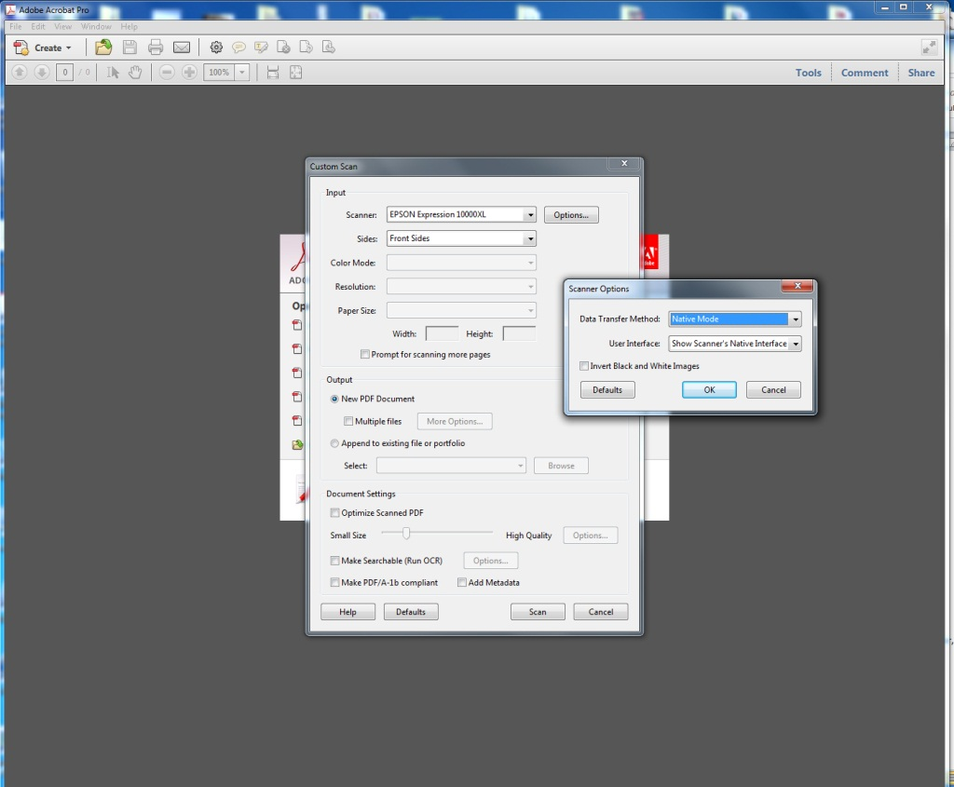

1. ***Scan according to the Epson Scan Flatbed Scanning instructions***.
2. Repeat for all pages to be scanned in the document.
3. To Save go to File🡪 Save as🡪 pdf…🡪 and name it according to your naming conventions.

**To create a pdf from jpeg and/or tiff files**

1. Turn on scanner before you open applications.
2. Open Adobe Acrobat Pro
3. Click Create🡪 Combine files into single pdf…
4. A dialog box will appear asking you add files.

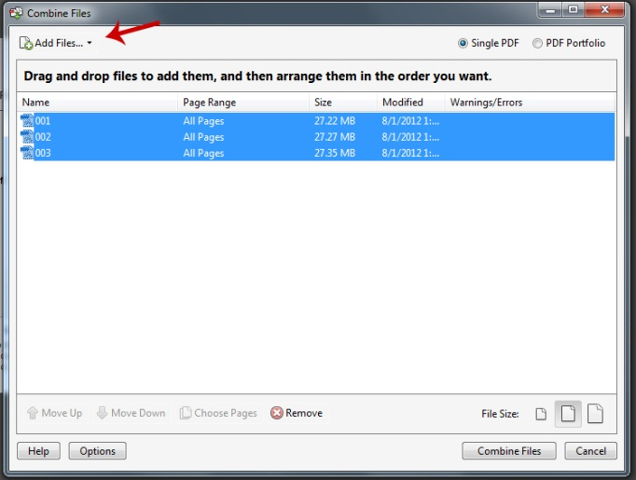

1. Add the files you want in the single document (if they are named with serialization, they will be added in the correct order. Hold down the shift-key to add multiple files at one time). Click combine files.
2. You can see all of you pages in thumbnail form to the left of the program by clicking on page thumbnails.

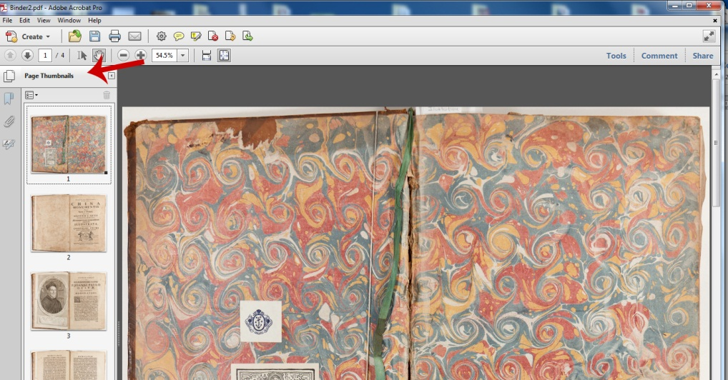

1. To Save go to File🡪 Save as🡪 pdf…🡪 and name it according to your naming conventions.

**Adobe Acrobat Pro: Additional Information**

The left side of the program shows Page Thumbnails. You can drag page thumbnails to correct page order if necessary.

The right side of the program has helpful tools. Under pages you can Rotate, Replace, and Crop.

