**Using Photoshop for scanning and creating Tiffs and jpegs** (8/2012)

1. Turn on scanner before you open applications.
2. Open Adobe Photoshop
3. Go to File🡪 Import🡪 (????)…
4. ***Scan according to the Epson Scan Flatbed Scanning instructions***.
5. After your image has been scanned and appears in Photoshop, you may need to make adjustments.
   * **To rotate**: Click on Image🡪 Image Rotation🡪 then choose how you want to rotate
   * **To Crop**: Use the crop tool, make sure the *width*, *height*, and *resolution* are left blank.

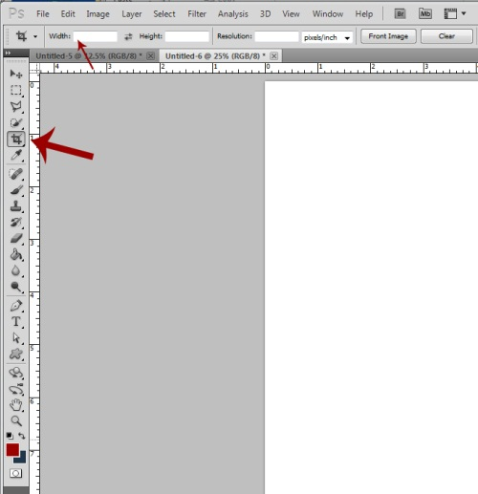

* + **To Check and/or Change your Image Size**: Click Image🡪 Image Size…

The dialog box below will appear. You can see the pixels of the image, document size, resolution, and byte size. *Width* and *height* should always be linked when making changes to the size of an image.

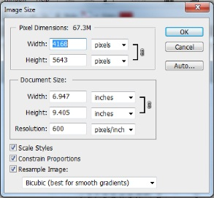

* + **To adjust levels:** Making adjustments to levels will help you refine the histogram of your image in photoshop, making it appear clearer or brighter without losing too much information. 1.) You first click on the levels icon which will add a layer to your image. 2.) Then you adjust the histogram by moving the left or right triangle to the edge of the histogram (where the information starts to appear, see 2🡪 3). Do not move the arrows beyond where the “hill” starts, or you will lose image information.

1. 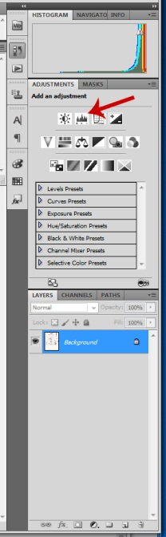 **2. 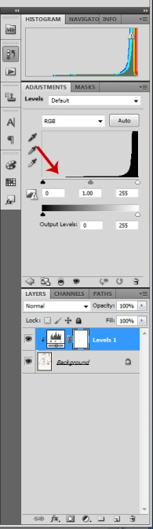 3.** 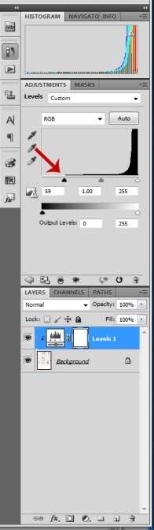
2. **Saving tiff files in Photoshop**. Go to *File*🡪 Save as. A Save As dialog box will appear. Choose the location you want to save the file, name the file according to your naming conventions, and choose the format you would like to save your file in (Tiff or Jpeg), then click *Save*.

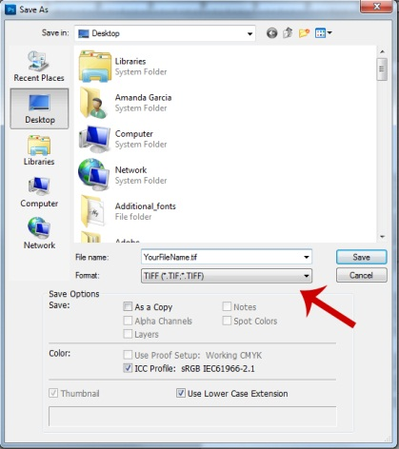

1. It is best to save your Tiff file with no image compression. That way you maintain the maximum image quality. Choose None.

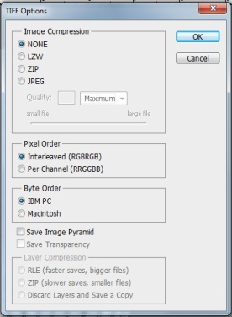

1. **Saving jpeg files in Photoshop**. Go to *File*🡪 Save as. A Save As dialog box will appear. Choose the location you want to save the file, name the file according to your naming conventions, and choose the format you would like to save your file in (Tiff or Jpeg), then click *Save*.

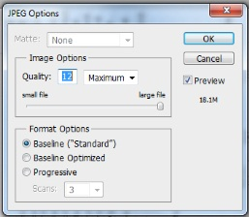

For Jpegs, this dialog box will appear. Be sure that for image quality you have it saved at high to maximum (8-12). Otherwise the image will be compressed, losing a lot of image quality.