Imaging Terms
RESOLUTION - The number of rows and columns of pixels in an image. It is the ability to distinguish fine spatial detail. The spatial frequency at which a digital image is sampled (the sampling frequency) is often a good indicator of resolution. This is why dots-per-inch (dpi) or pixels-per-inch (ppi) are common and synonymous terms used to express resolution for digital images.
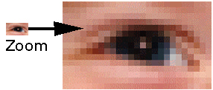
Pixels: Individual pixels can be seen by zooming in an image.
Image FILE SIZE is calculated by multiplying the surface area of a document (height x width) to be scanned by the bit depth and the dpi².
Histogram: An image histogram is a type of histogram that acts as a graphical representation of the tonal distribution in a digital image. It plots the number of pixels for each tonal value. By looking at the histogram for a specific image a viewer will be able to judge the entire tonal distribution at a glance.

