Consider the following simple network (very similar to example in talk, just with longer and more fiber links):
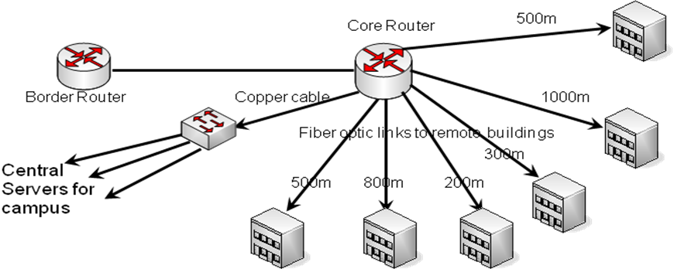
Use the tables below to develop pricing for a network based on gigabit Ethernet and 10gig Ethernet links for all fiber types (OM1, OM2, OM3, OM4, and G.652.D).

Standard | Cost | OM1 | OM2 | OM3 | OM4 | G.652.D
100baseFX | $125 | 2km | 2km | 2km | 2km | No
1000baseSX | $100 | 275m | 550m | 1km | 1.1km | No
1000baseLX/LH | $169 | 500m | 500m | 500m | 500m | 10km
10GbaseSR | $475 | 33m | 82m | 300m | 550m | No
10GbaseLRM | $785 | 220m | 220m | 300m | 400m | No
10GbaseLR | $495 | No | No | No | No | 10km
10GbaseER | $6050 | No | No | No | No | 40km

Fiber Type | Budget Cost per km
OM1 | $4,270
OM2 | $2,854
OM3 | $7,248
OM4 | $7,990
G.652.D | $938

Here are some worksheets to use.
What is the total installed fiber length?
Cost of 1 Gigabit Network
Fiber Type | Fiber Cost | Optics Used | Total Cost
OM1
OM2
OM3
OM4
G.652.D

Cost of 10 Gigabit Network
Fiber Type | Fiber Cost | Optics Used | Total Cost
OM1
OM2
OM3
OM4
G.652.D

